

Prepared by:

**Gerber Technology**

**YuniquePLM**

**Image Folder**

Images are an extremely important part of the lifecycle of products. Being able to generate or reference images quickly can speed development and enhance communication related to product details. While there are many places in YuniquePLM™ where images can be populated, the images are ultimately stored and managed in the Image Folder.

**Accessing the Image Folder**

To access the Image Folder click on the label on the far right of the Desktop Window.

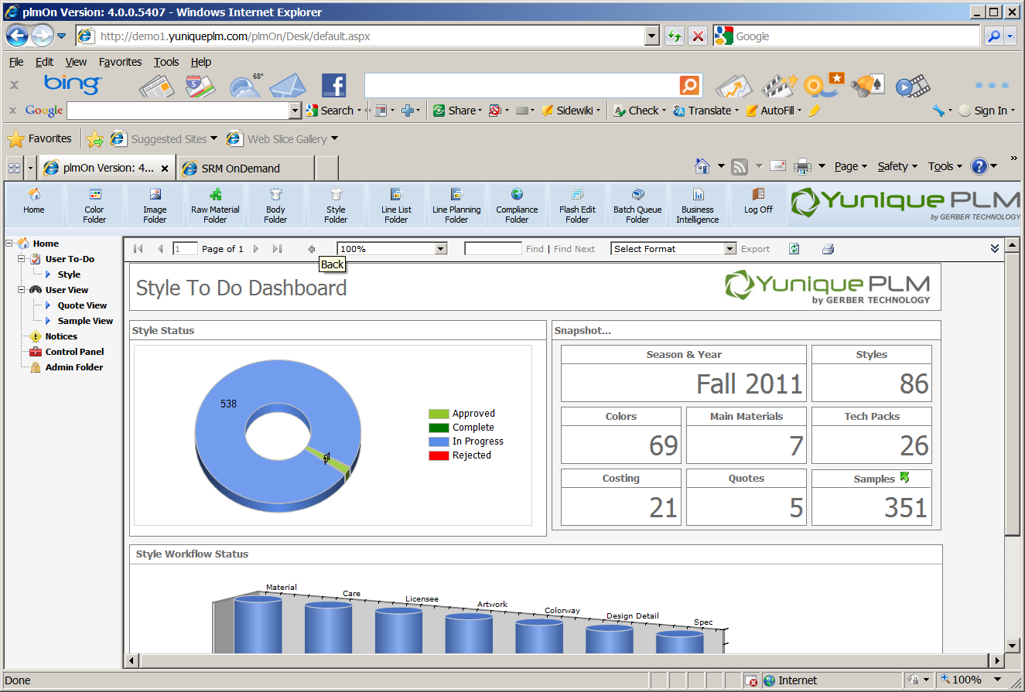

On the left side specific Image Folder categories will be listed, and on the right side the actual image files will be displayed. The categories listed as Image Folders are configurable and can be established to meet specific company needs. Permissions can be established based on the Image Folder categories, so that users will have access to only the Image Folders that they need for doing business. The filters across the top of the images window assist with faster searching by entering the appropriate data. The green arrows across the top of the window will help to navigate page by page. The display can be set to display images in ascending or descending order.

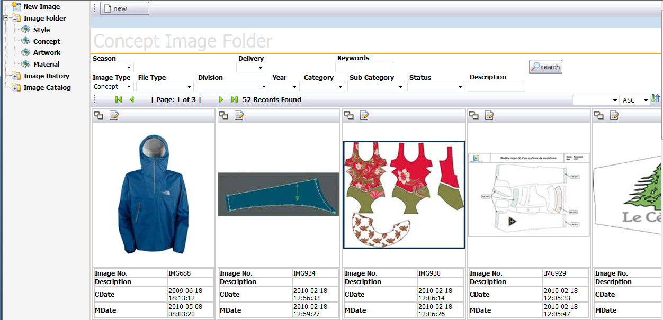

When data is entered into the search fields the system will filter the images based on that information.

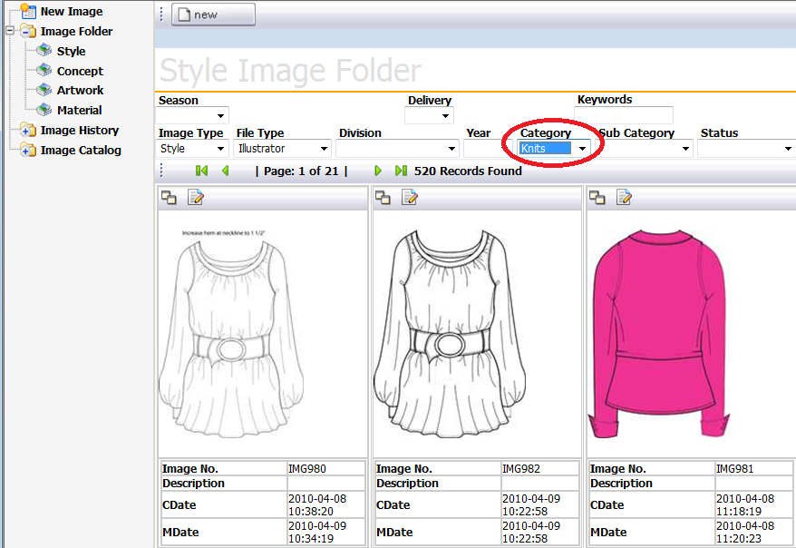

On the left side of the window is the Image History node. This will display the images that have been most recently viewed or edited for each individual user on the right side of the window.

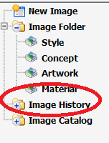

**Adding Images**

Uploading

There are multiple ways to add images to the Image Folder in YuniquePLM™. The most straight forward method is to Upload an image. This means that the image will be retrieved from the network or an external media device accessible to YuniquePLM™. To upload a new image either click on the New Image node on the left side of the window or click on the New button at the top on the right side of the window.

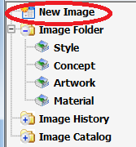

Next select the Image Type label from the drop down menu.

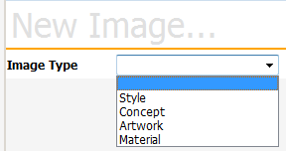

**Important:** Select **Upload** from the drop down list in the File Type field. This action will cause the Select File to Upload field to be presented across the top of the window. Browse to the network location of the image file to be uploaded. The file path will display in the field. Then enter data into the other property fields provided to associate additional information with the image being uploaded.

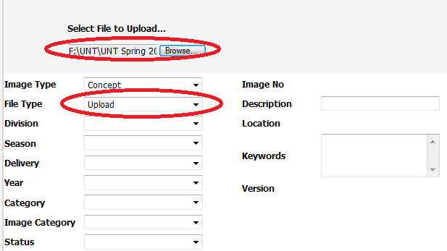

Once all appropriate image property data has been added, click on the Save button across the top of the screen.



The newly uploaded image will be displayed along with the image properties on the right side of the window.

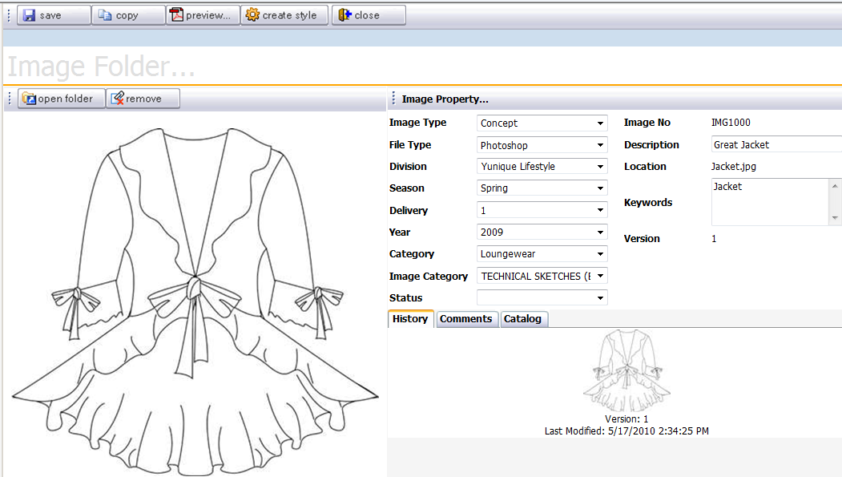

Copy Image

Images can also be added by making a copy of an image that is already in the Image Folder. To copy an image, click on the select icon in the upper left corner of the representative image that will be copied.

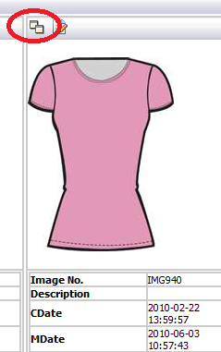

When the image file opens, click on the Copy button at the top of the window.



A dialog will be presented to verify that the image should be copied. Click OK to verify this action.

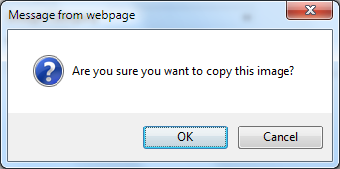

When the image has been successfully copied a message will be displayed below the representative on the original image file. Click on the Close button at the top of the window to exit the file that was just copied.

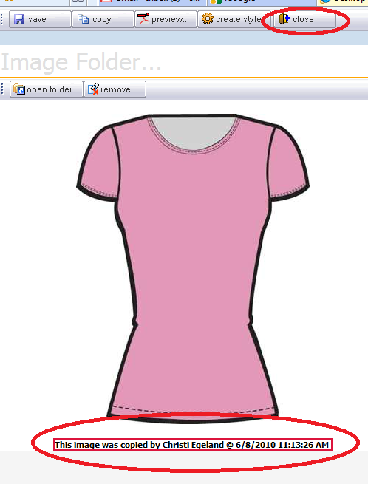

Creating New Images

A third way to add an image is to create one using a CAD software application that has been made accessible for use from within the YuniquePLM™ program. For example, black and white flat sketches might be prepared using the Adobe Illustrator software application launched from the YuniquePLM™ Image Folder. To create and add a new image, select the New Image node on the left side of the Image window or click on the New button on the right side of the window.



Next select the Image Type label from the drop down menu.



Next select the appropriate File Type. In this instance the File Type will be the CAD software application being launched to create the new image.

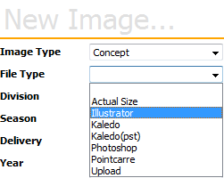

Fill in any additional information in the data fields for the image being created and click on the Save button at the top of the window.



Once the new image record has been saved, click on the Open Folder button presented near the top of the window.



Next click on the template file name presented to launch the selected CAD application software.

**FLAG**

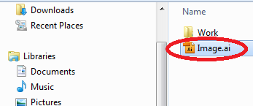

Once the template is selected, the associated CAD application will then launch and an image can be created.

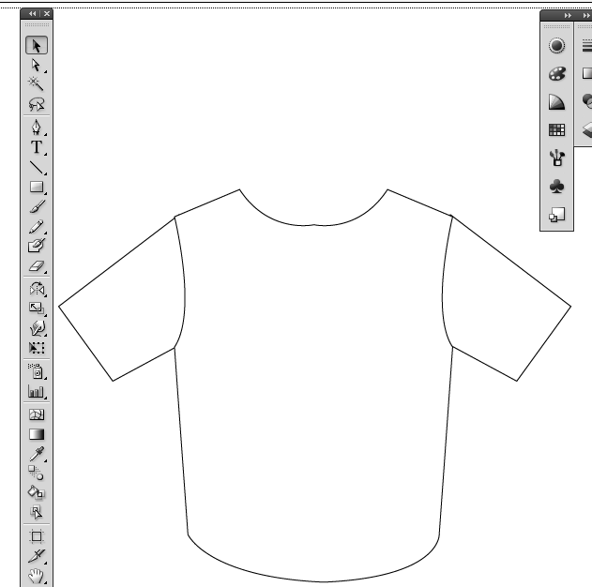

When the image is saved in the CAD software and the application is closed, click on the Update button at the top of the Image folder.



The new representative will be displayed in the Image folder with the associated data to the right of the image.

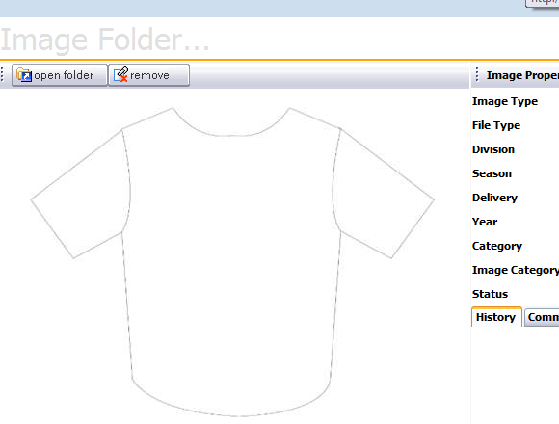

**NOTE:** Setting up an association to proprietary CAD software applications is a function that will be performed by a Gerber YuniquePLM ™ consultant and/or a representative of the company administrative team. Typically this will only need to be done one time unless there are extenuating circumstances, such as changing server locations.

**Editing Images**

Throughout the lifecycle of a style changes will typically occur that are ultimately reflected in the images managed in YuniquePLM™. To make a change to an image that is stored in the Image folder click on the Open Folder button directly above the representative image.



The original image file will be presented and the native CAD application will be launched to make changes to the image file.

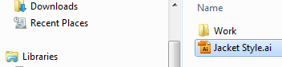

Once all changes have been made the image should be saved and the CAD application should be closed. When the image folder screen is visible again, click the Update button to refresh the image file and display the changes.



When changes have been made to an image a history is maintained of all of the previous versions of that image. This acts as both a reference library as well as a convent way to reinstating old versions of images. The variation history of each image is displayed on the history tab in the lower right of the window.

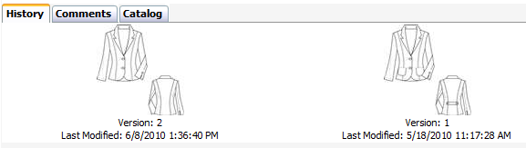

The comments tab will maintain the ongoing dialog information associated with an image file. This may be information explaining the version changes or general discussions regarding the image. Clicking on the Comments tab will display any comments associated with the image. Click on the Add New icon to add a new comment to an image.

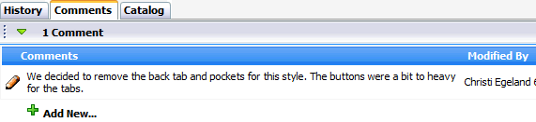

**Image Catalog**

Individual images that are added to the Image Folder can be grouped together to create Image Catalog(s). Individual images can belong to multiple image catalogs at the same time. Creating a catalog(s) will allow groups of users to access and organize image files, with little or no additional information associated with these files. For example, digital photographs from a particular buying trip can be grouped together and labeled “European Buying Trip 2011”. These images can ultimately be used to generate new styles or they can simply be referenced directly from the Image catalog area.

To create an Image Catalog, click on the Image Catalog node on the left navigation and then click on the New button presented across the top of the screen on the right.

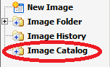

Fill information into all of the data fields presented for the catalog being created, then click on the save button at the top of the window.

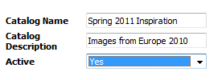

Once the record has been saved in the database, images can be added to the catalog. Click on the Image button across the top of the window to begin the process.

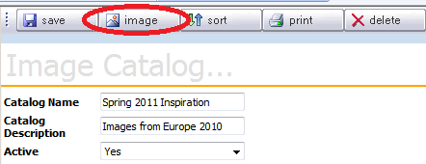

To add images that already exist in the Image Folder to catalog, click on the Add button at the top of the window. Thumbnails of images within YuniquePLM will be displayed. The search results can be filtered using the data fields across the top of the window.

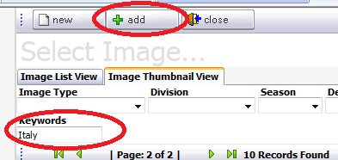

Place a check mark in the upper left corner of the image thumbnail(s) to be added to the new catalog, and then click on the Add button across the top of the screen.

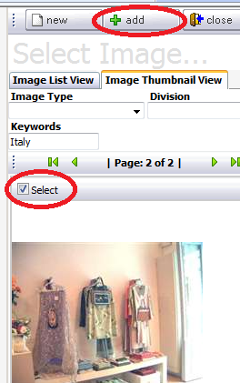

Once the images are successfully added to the catalog, they will be displayed on the left navigation.

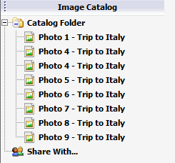

New images can also be uploaded to a catalog from a network location outside of YuniquePLM™ or generated using a proprietary CAD software application that is accessible from within the YuniquePLM™ program. Please review the Adding Images section of this document for directions. Any images added directly to a catalog will also exist independently in the Image Folder.

**Deleting Images**

To remove images from the Image folder select the image file and click on the Remove button directly above the representative image.

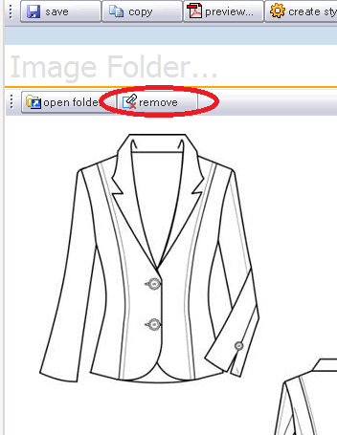

Place a check in the box to the left of the version(s) to be deleted and click on the Delete button across the top of the window.

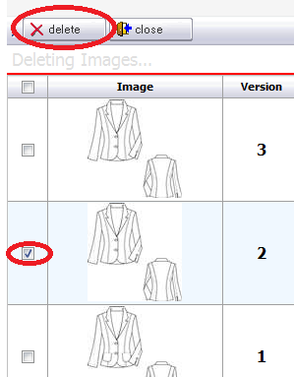

**Preview (Printing the Image File)**

From time to time the need will arise to have a hard copy of an image file. To print an image file click on the Preview button across the top of the image file window.



Select the print layout by clicking in the circle to the left of the desired option and then click the Preview button at the top of the window.

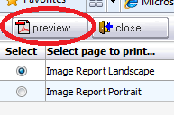

The print preview will be generated and displayed in a PDF format. When it has completed, choose the Print option from the File menu or click on the printer icon to send the file to a physical printer.

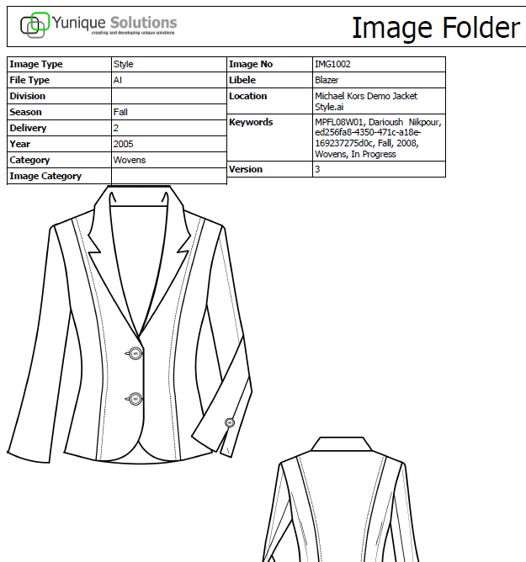

**Creating New Styles or Materials**

Since very often images are the first step in the product development process, the ability to generate a new style or material item directly from an image file is available in the YuniquePLM™.

New Styles

To create a new style folder open up an image file that has been classified with the Image Type of either a Style or Concept or click on either the Style or Concept Node on the left navigation.

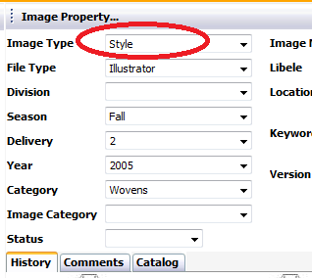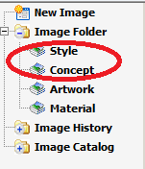

Click on the Create Style button across the top of the image file window.



Set the Active status to Yes, Fill in the Style Type, and select the appropriate Workflow Type then click the Next button across the top of the window.

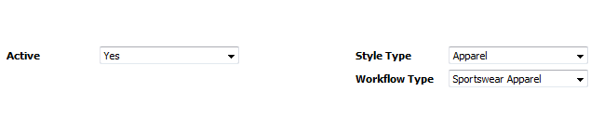

Next fill in any additional data fields presented and click the Save button across the top of the window.

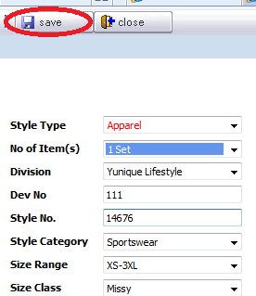

The newly created style folder will be presented with the thumbnail of the image that was used to generate the style.

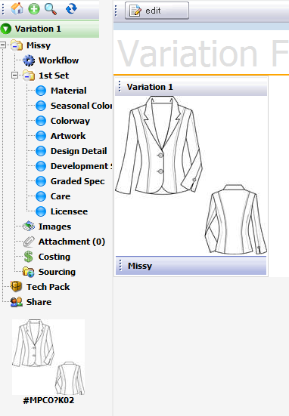

For more information on creating and working with style folders please refer to the Style Folder section of the documentation.

New Materials

To create a new material folder open up an image file that has been classified with the Image Type of either a Material or Artwork or click on either the Material or Artwork Node on the left side of the window.

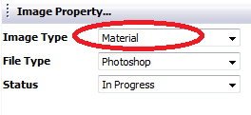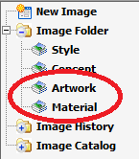

Click on the Create Material button across the top of the image file window.



Select the Material Type from the drop down list.

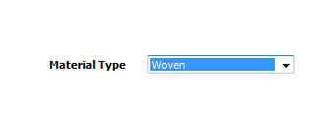

Next fill in any additional data fields presented and click the Save button across the top of the window.

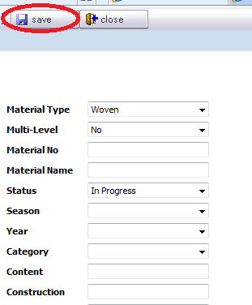

The newly created material file will be presented with the thumbnail of the image that was used to generate the material.

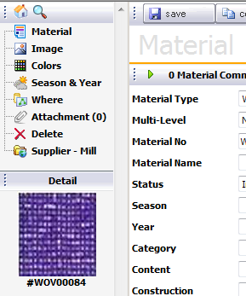

For more information on creating and working with raw material information please refer to the Material Folder section of the documentation.